The Forsyth Chapter Scoop

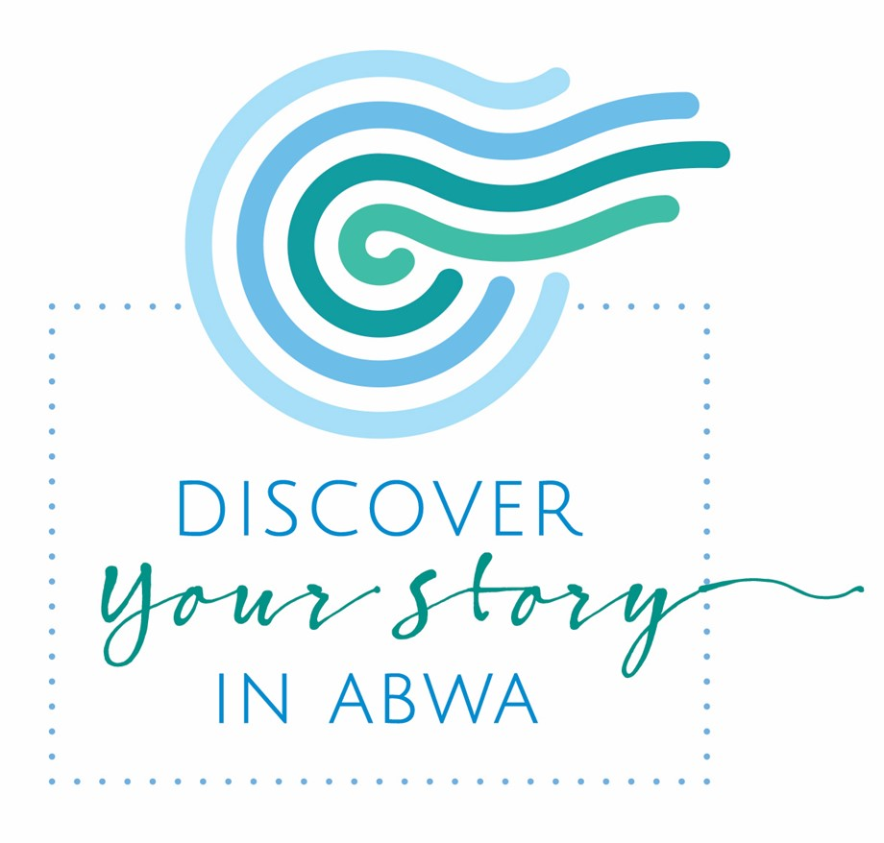

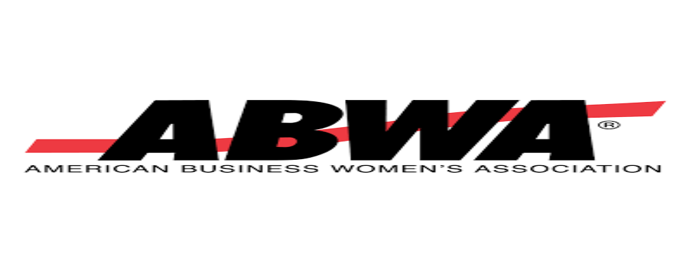

Winston-Salem Chapter

Inside this issue:

1 2022-2023 Executive board salute
2 President’s Message
3 Summer Presentations
4 Scholarship Award
5 “ABWA About the Town”
6 “About the Town”
7 Upcoming Events
8 Welcome New Members
9 Chapter Awards
10 2023-2024 Executive board
11 Proud Code of Conduct

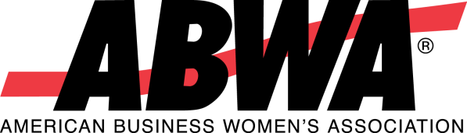

The mission of the American Businesswomen’s Association is to bring together businesswomen of diverse occupations and to provide opportunities for them to help themselves and others grow personally and through leadership, education, networking support and national recognition.

A League of the American Business Women’s Association

The Forsyth Chapter of ABWA is one of the many ABWA Chapters and networks in the Piedmont Triad Area. Our chapter has been in existence for more than 40 years. We invite you to visit with us or another ABWA chapter or network to learn more about this national organization. We offer opportunities for education, personal and professional growth, networking, friendship, and fellowship.

The Forsyth Chapter would like to give a special thank you to the 2022-2023 Executive Board. While several ABWA chapters nationwide collapsed, the Forsyth Chapter not only weathered unforeseen events such as Covid, dwindling membership, changes in Executive board members and meeting locations, we have flourished. Our membership and participation are increasing. We have had a wonderful fundraising year, which allowed us to award an Impact Scholarship in 2023 to a deserving student. We look forward to another prosperous and progressive year. Job well done!
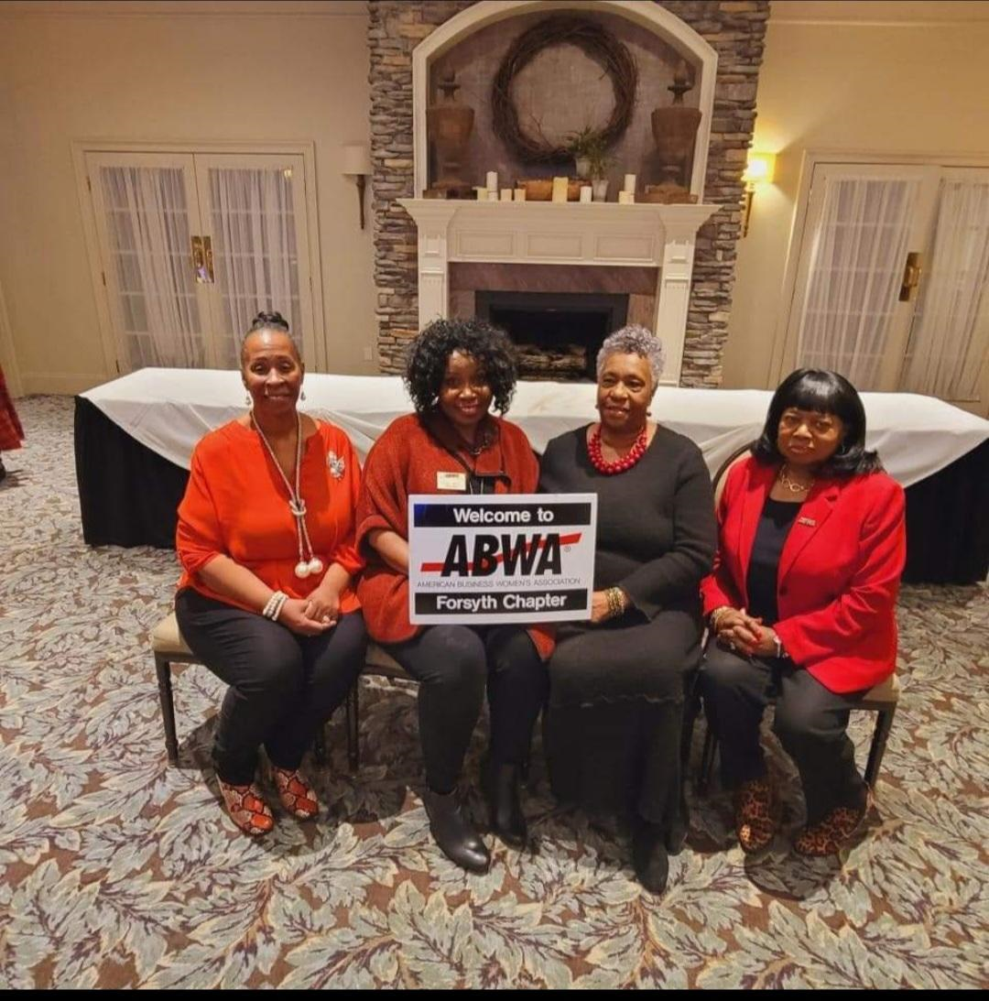
2022-23 Executive Board: Michelle Ferguson-Miller, Elisa Wells,
Dr. Fran Oates-Bates, and Mosé Belton-Strait

President’s Message

My Dear Forsyth ABWA Chapter,

It has been my great honor and pleasure to serve as your chapter president this past year. We had some ups, downs, and all arounds, but by God’s grace, some hard work, a whole lot of help from our amazing executive board as well as this fantastic membership, we got our train on the track, headed in the right direction. Now let’s keep this train moving to reach our best practices goals and attain the vision set forth in our beginning by simply helping other women win.

You all have been phenomenal in sharing the vision of ABWA by inviting others each and every month. Because of your commitment to help others discover their story in ABWA we have almost quadrupled our membership and we are still growing. I am so excited about the future of ABWA-Forsyth. I want to publicly thank the entire membership for standing with me to move our chapter forward. Teamwork is truly the dream work, and I am so proud to serve as your leader. Together we made great strides in growing our chapter and building excitement around everything ABWA.

We stood on our motto, “ABWA Forsyth women helping other women win.” And we have certainly encouraged women to discover their story in ABWA. Now we have an awesome gentleman to join us, which will not only shine a light on different perspectives but also diversify our chapter even more. I am excited about our future ABWA-Forsyth. As new leadership begins in August, I ask each of you to keep the excitement and support for this new board. Together is how we move forward. In the words of King George that we often imitate, “This train gonna keep on rolling.”

I absolutely love and appreciate each of you, and there is nothing you can do about that. We will walk the national stage together in October, stronger and better than when we started. I believe that when awesome folks get together, amazing things happen. Let’s finish strong and have great participation for our upcoming Brunch on July 22 and our next meeting on July 27. We are expecting a strong finish to our calendar year. Let’s go,

Yours in ABWA,

Michelle Miller, President
ABWA-Forsyth Chapter

“I’ve learned that people will forget what you said, people will forget what you did, but people will never forget how you made them feel. “ - Maya Angelou

Summer Presenters Enlighten Us

In May, Mare Hutchinson presented on “Lifting Your Leadership Values.” We each identified our top 10 individual values and discussed how they impact our personal and business life.

In June, Dr. Amber Baker, NC State Representative shared her story of challenges, faith, and her passion for education. Contributions may be made to vote4amberbaker.com.

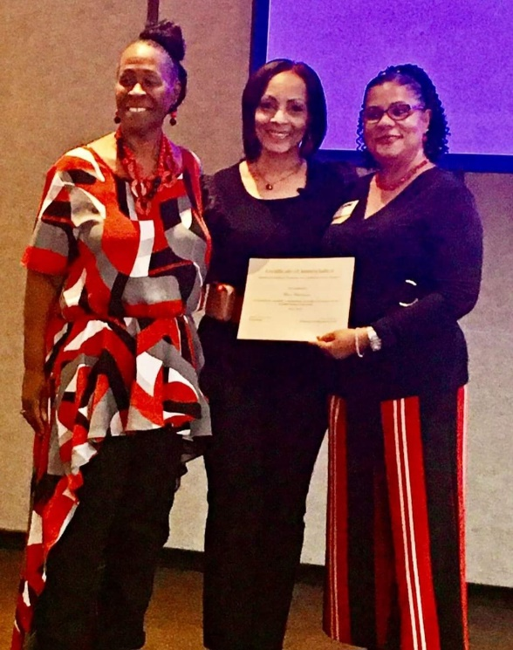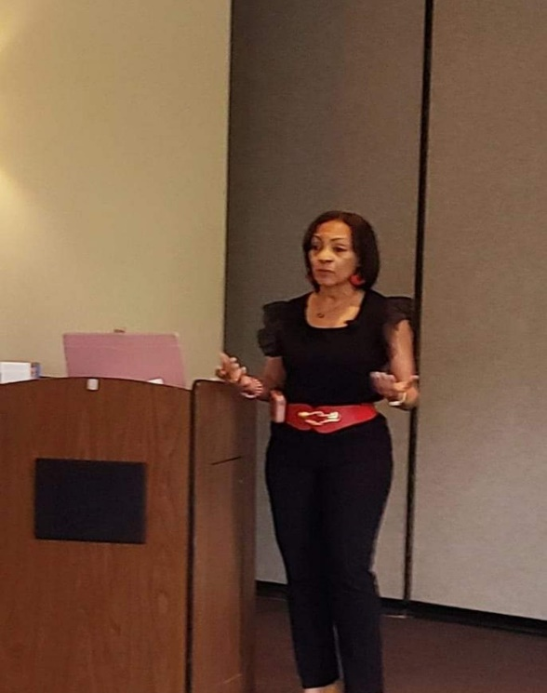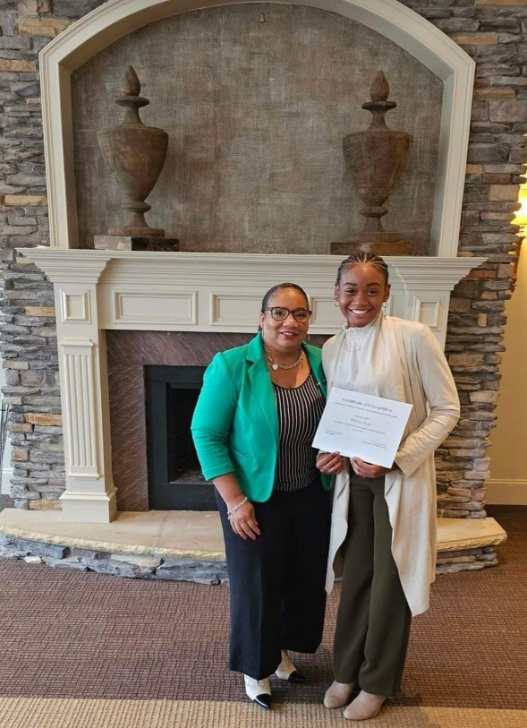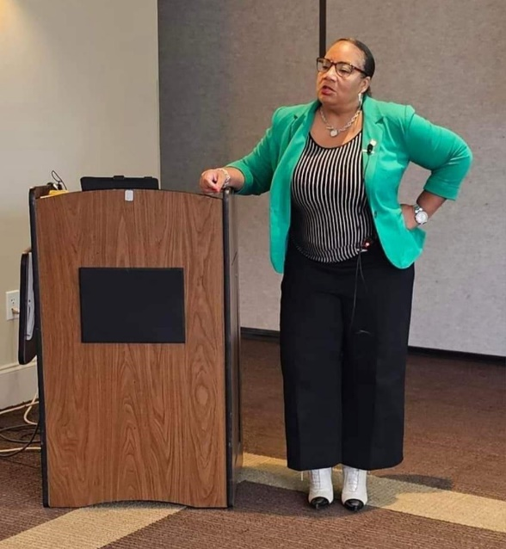

ABWA Forsyth chapter congratulates Mekayla Beard, 2023 Stephen Bufton Impact Scholarship Award Recipient. We wish Mekalya great success as she embarks on her college journey.

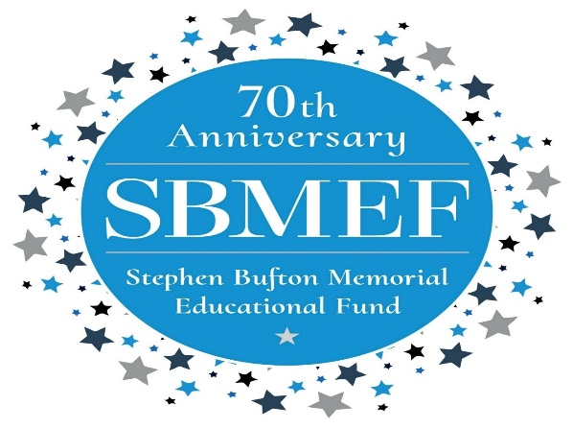

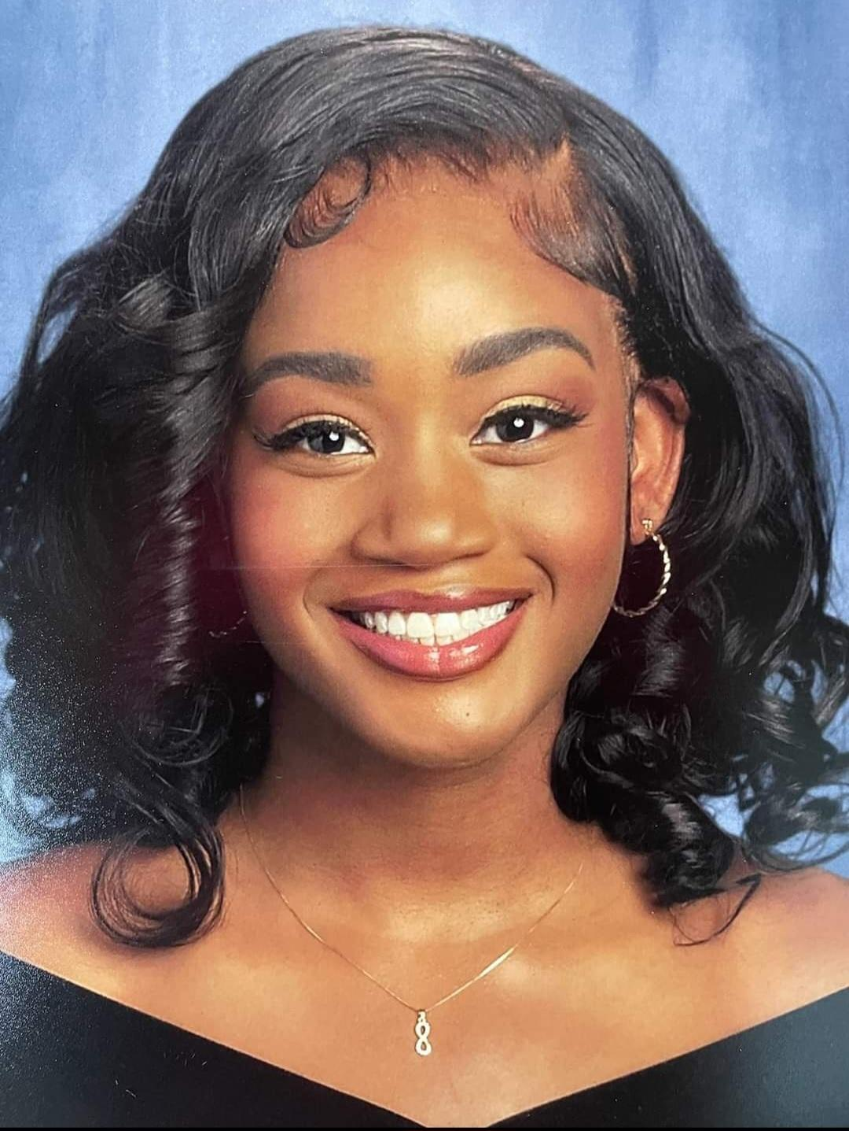

Forsyth Chapter supporting our members and the community

“ABWA about the Town”

Marviette Usher’s Branding Event

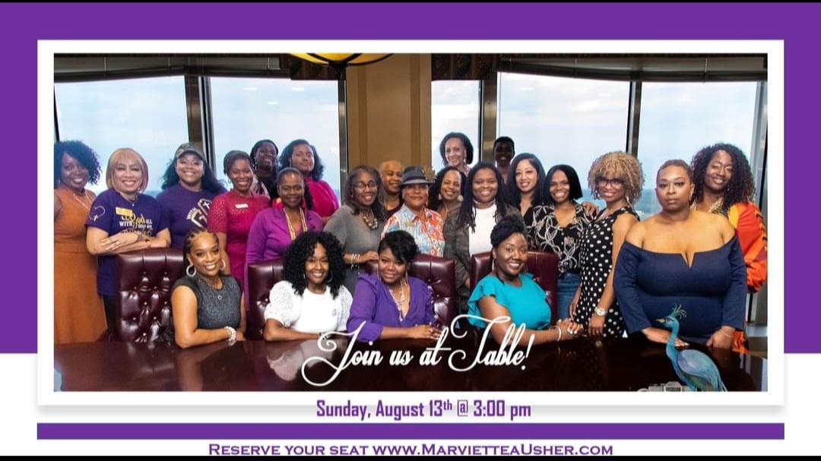
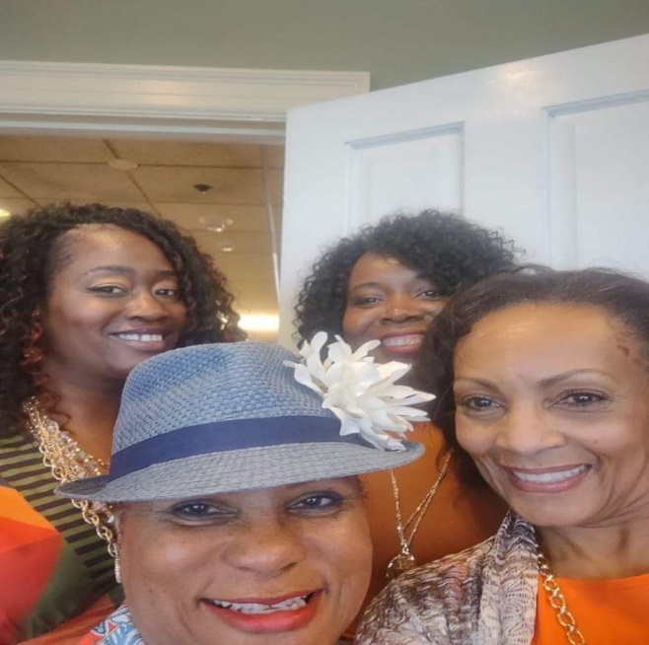

Heart of the Piedmont ABWA Chapter
2023 Symposium
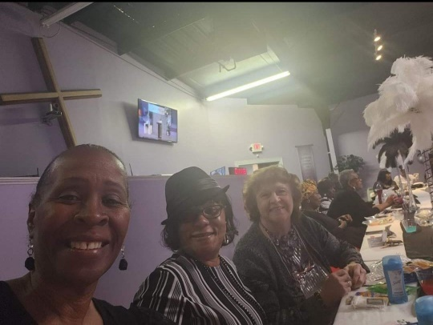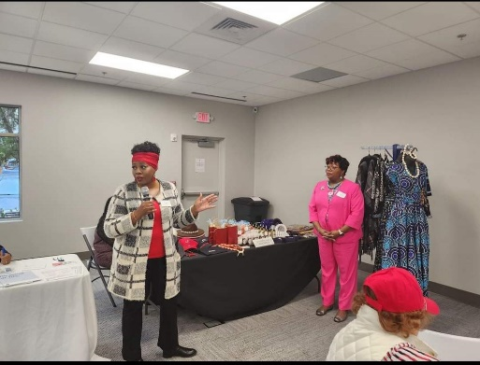
.
.
.

“ABWA about the town”
Debra Terry Women’s Conference: Why Didn’t Someone Tell Me

Tammy Watson Financial Pathways
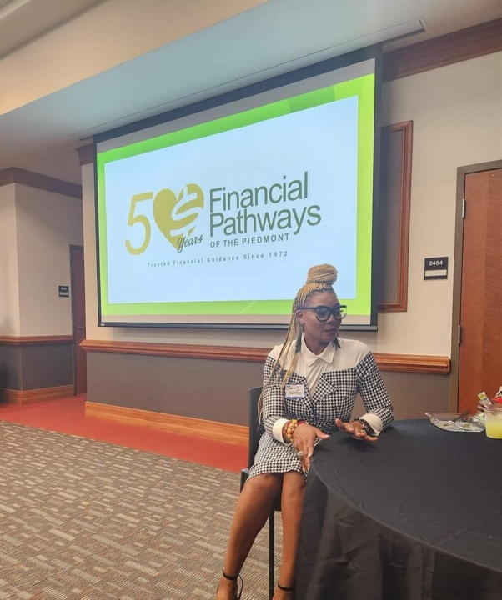
Award Ceremony

Anticipate Exciting Events and Guest Speakers

Speakers
August: Erika Glenn, VP and General Manager, Care Management, CVS
September: Olajumoke Michael, Program Director, Women’s Business Center
October: Abrea Armstrong, Wake Forest School of Business graduate, Former President, Winston Salem Urban league Young Professionals.

Fundraisers
September 16th, 2023, Fundraiser: Shelton Vineyards
September 16th,2023: ABW Day-Greensboro, NC

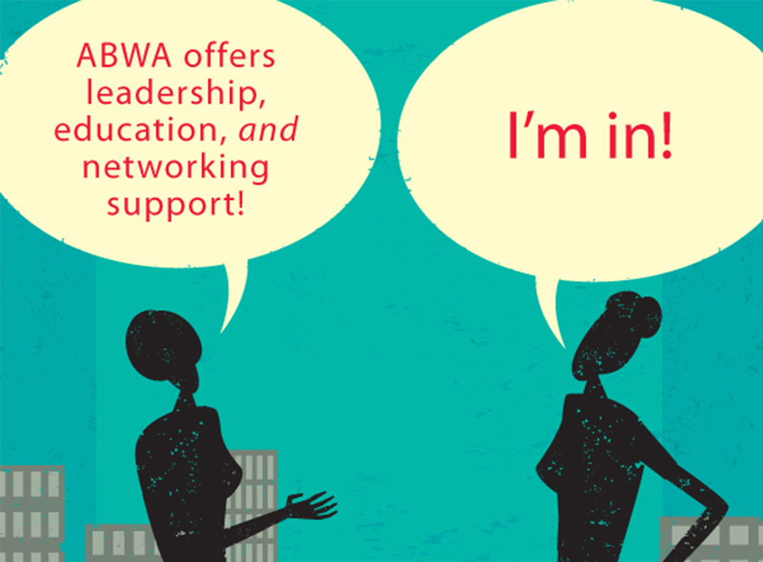

WELCOME!
New members of the ABWA Forsyth Chapter

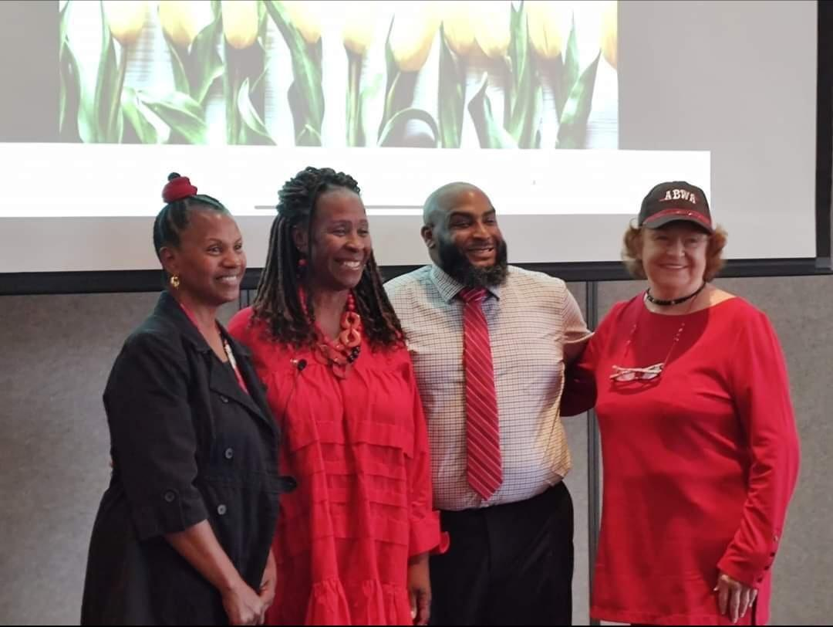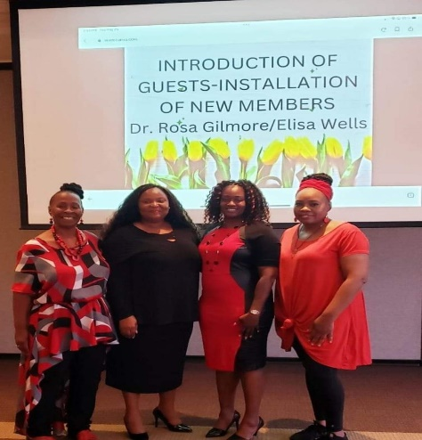
Pictured:
Etta Deans
Benjamin Goodwin
L. Marie Roberts

Not Pictured :
Dr. Michelle Outlaw
Carla McCoy
Gabrielle Springs
Rebecca Lewis
Bridget Perkins-Wells
Makayla Beard

(installation July 27)

2022-2023 ABWA Awardees
ABWA Top Ten Nominee
Michelle Ferguson-Miller
Also will compete on the national ABWA level for Top Ten Award

Forsyth Chapter Woman of the Year
Elisa Wells

Protégé Award
Mare Hutchinson
(For valuable contribution to her league in her first year of membership)

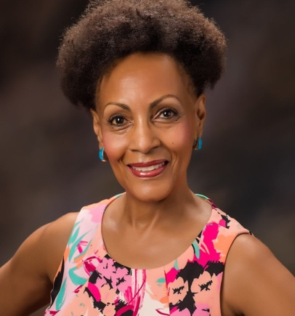

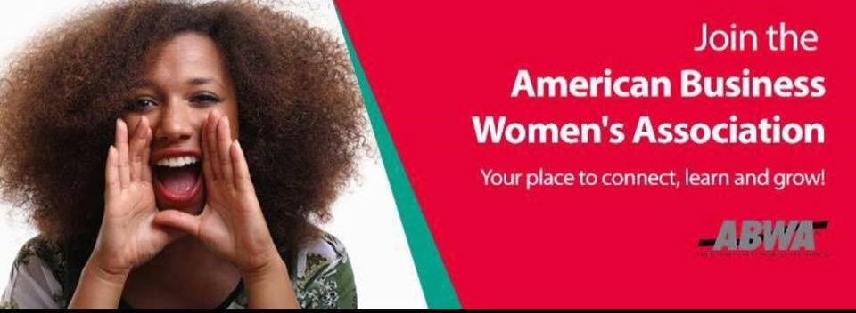

Welcome Aboard New Members!

Synergize With Our New 2023-2024 Executive Board

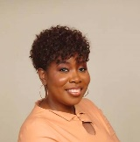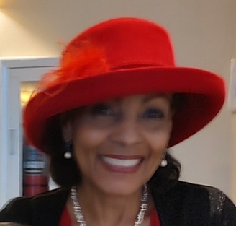
Elisa Wells Mare Hutchinson
President Vice-President

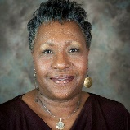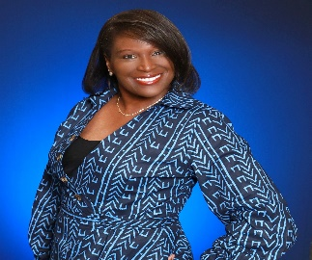
Dr. Fran Bates Oates Angela Brandon
Secretary Treasurer

“Synergy” is our new board’s motivational word for the way forward. We have begun board meetings and are bursting with aspirations of inclusive teamwork and enriching experiences for our chapter.

2023-2024 Executive Board

ABWA’s Proud Code of Conduct

Members serve as goodwill ambassadors for the American Businesswomen’s Association.

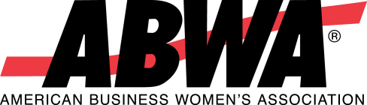
Members do not allow personal beliefs and convictions to interfere with the representation.
of ABWA’s mission.

Members always treat other member colleagues, guests, vendors and sponsors with honesty, respect, fairness, integrity, responsibility, kindness, and in good faith.

Members maintain compliance with ABWA National, Chapter, and Express Net-work Bylaws.

Members do not use their personal power to advance their personal interests.

Members will strive for excellence in their professions by maintaining and enhancing their own business knowledge and skills and by encouraging the professional development of other members.

A League of the American Business Women’s Association

Email: info@abwaforsyth.org
Visit us online at www.abwaforsyth.com
www.abwa.org

